Katelyn Warren
Dr. Celeste Roseberry
CSAD 112 8:00 am
4 October 2023
Children's Book Assignment
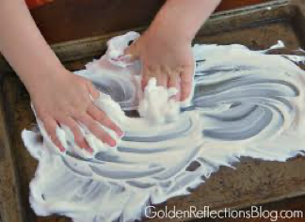
Book 1: "The Snowy Day” By: Ezera Jack Keats

Vocabulary word: Snow

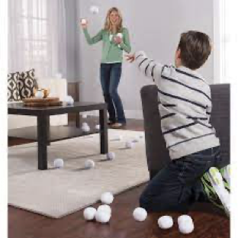
This book depicts a day in the life of a child on a snowy day including what activities and things a child would do on such a day. For a sensory play activity related to this book, the student and I will use shaving cream on the table. We will be able to do some of the activities seen in the book like using a stick to make tracks in the shaving cream, using a finger to make footprints in the snow, and making a snow angel. I will use this opportunity to ask the student what they would do on a snow day and suggest activities like sledding, a snowball fight, making a snowman, etc.

Morphology: -ed suffix

Throughout the book, there are multiple mentions of activities with the -ed suffix. After reading the book initially with the student, I will then prompt them to read the book with me again and find words with -ed suffixes as we read. As the student points out the words with -ed suffixes, we will write them down on a whiteboard with an expo marker and underline the -ed suffix. After we finish the book, the student will say each word with the -ed suffix written and after each desired response I will throw an artificial snowball for the student to catch. We will repeat this process with every word written. After our work is done we can engage in a snowball fight together.

Book 2: "Pete the Cat I Love My White Shoes” By: Eric Litwin

Vocabulary Word: Shoes

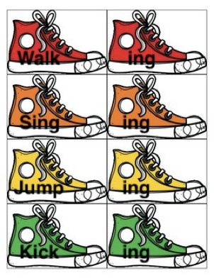
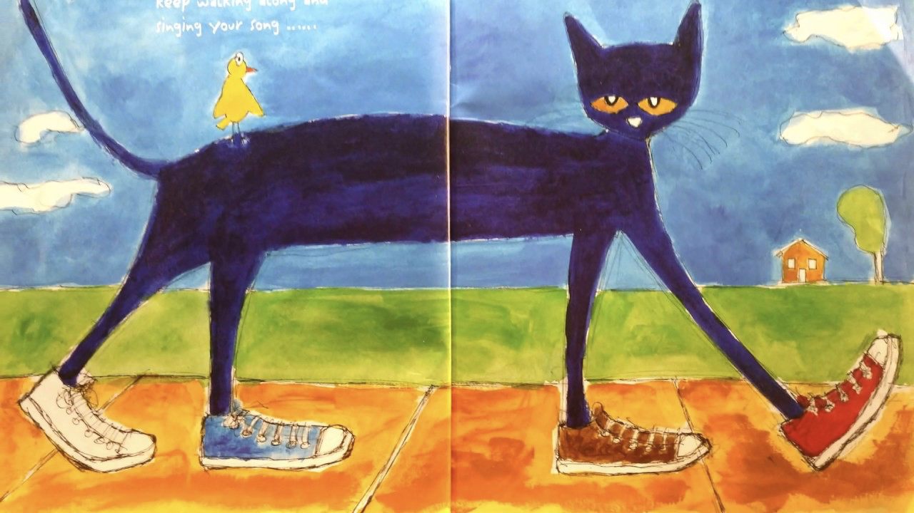
In the book, Pete the Cat is wearing his shoes and keeps stepping in different piles of things, making his shoes different colors. Together the student and I will watch a small video to go along with the book "Pete the Cat: I Love My White Shoes" by White Board Entertainment Studios on YouTube. After the video, I will talk with the student about the different actions Pete did with his shoes like walking and stepping. After pointing out the actions Pete did in the book, I will ask the student "Can you think of some things you do in your shoes?" If the student is having trouble I will suggest and demonstrate some activities such as kicking, jumping, putting on shoes, tying shoes, etc. After that, I will invite the child to act out some of the physical actions related to their shoes as discussed earlier in the therapy session.

Morphology: Present progressive -ing verbs

In the book, there are different present progressive -ing verbs, such as walking and singing. For a matching activity, I will prepare a file folder with Velcro and different colored shoes. Each set of shoes will have a free morpheme and a matching bound morpheme printed onto them. In this activity, the student will be asked to read the first free morpheme with me and then we will discuss the word. I will then prompt them to "make a match" and the student will match the same color -ing shoe with the free morpheme shoe listed. After they have made their match, I will encourage the student to read the free and bound morpheme together. We will repeat this until we have matched all the shoes.

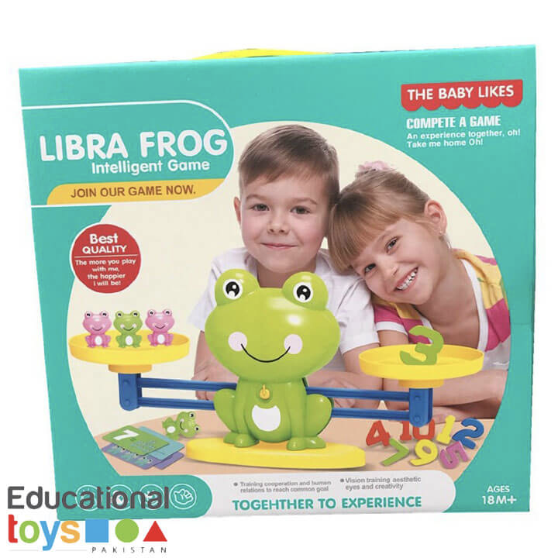
Book 3: "Five Green and Speckled Frogs” By: Constanza Basaluzzo

Vocabulary Word: Frog

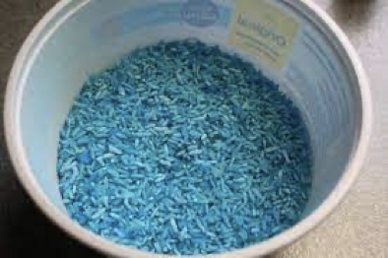
In the book, there are five frogs in their natural environment. After reading the book with the student I will have a prepared craft using a piece of construction paper, a glue stick, a black crayon, 2 Googly Eyes, 1 green frog body, and 1 blue blob cut out for water. I will talk with the student about the frogs in the book, going piece by piece with the elements for the craft I have prepared. I will then prompt the student by asking questions like; "In the book where did the frogs live?" With this, I would like to establish that frogs live in or near water. After getting the desired response "water," we will start gluing the water cut out onto the paper background for the project. Next, I would invite the student to put the frog in his habitat by saying, "Let's put our frog in his home!" and hand the student the frog to glue onto the water blob. While gluing together the frog scene, I will engage the student by asking questions like: "What would you like to name the frog?” "What do you think frogs do in their home?” "What does your frog eat?"

Morphology: Plural -s suffix

In the book, multiple frogs are jumping into the water. To teach the plural -s suffix, I will bring blue colored sensory rice in a tub and five of the small frogs from the Baby Likes Libra Frog toy set. I will show the student one small frog and the student will respond with the plural -s suffix version of frog, “frogs”. Every time the student responds with the desired morpheme, they will get to put the frog in the rice. After repeating this process five times we will then reverse the process by finding the frog in the rice tub. As the student finds the frog I will ask "What jumps out of the water?" The student will respond with the desired target response "frogs". Afterward, the student can play with the rice in the bucket for sensory play.

