Caitlin Pearson

February 29th, 2024

CSAD112 Section 50

Children’s Book Assignment

*We’re Going on a Bear Hunt* by Michael Rosen

Vocabulary word: **Hunt**

This book tells the story of a father and his three children hunting for a bear. During their journey, the family must endure walking through a variety of elemental obstacles. Before the students arrive, I will tape pictures of elements from our story (grass, river, mud, forest, snow, and a bear) on various classroom walls. Once the students arrive, I will distribute papers with images reflecting those on the walls and explain that our first activity is going on a hunt in the classroom. Working together, we will find all the items posted on the walls. Once we have located all the items, students may return to the table and enjoy "Teddy Grahams" as a prize. After finishing our treat, I will read to them from my selected book. When finished, I will distribute stick puppets representing the characters from our story. I will read the story again, instructing the students to use puppets when necessary.

Morphology: **present progressive -ing verb**

Throughout this story, the characters engage in a variety of actions during their journey. Readers can observe the characters running and walking. On my whiteboard, I will display a picture of the family. We will discuss how the family performed each action in each scene. I will handwrite the words “run,” “skip,” and “walk.” After distributing binoculars, I will model and instruct the students to use them every time they see me add an “ing” to each word. After multiple practice sessions, I will then proceed to write other words such as “camp,” “bloom,” “hunt,” and “shout.” For retention, we will walk, hop, and skip across the classroom.

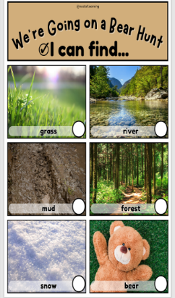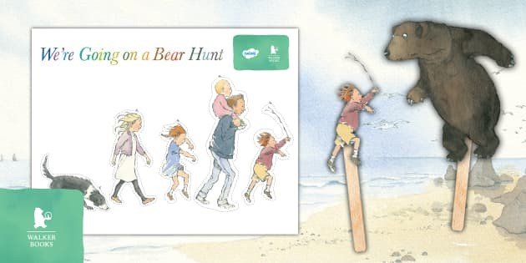

*The Little Engine That Could* by Watty Piper

Vocabulary word: **Transport**

This book follows the inspiring journey of a little blue engine who volunteered to transport toys and treats across the mountain. Despite being small, the train engine persevered and achieved her goal of delivering cargo to children in need. When the students arrive, I will place different pictures of various modes of transportation on the table: car, train, boat, and plane. Students will be instructed to use dot markers to mark the various pictures. During this activity, we will discuss each mode of transportation and how they differ from one another. After our discussion, I will read our selected book. Using a felt board, I will read the story again and allow students to place various trains throughout the narrative. We will discuss how the little blue engine was the only train that volunteered to transport the items over the mountain. Once finished, I will provide a sensory bin filled with trains for students to explore before returning to class.

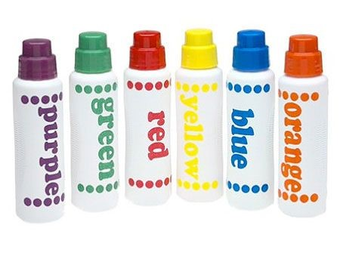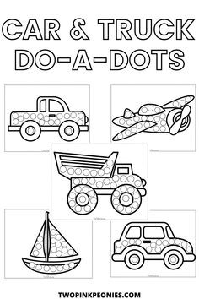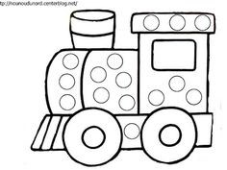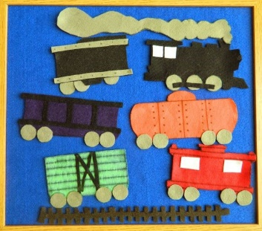   
   
Morphology: **-ly suffix**

To focus on the "-ly" adverbs, the students and I will discuss how each train in the book traveled. Some trains moved "slowly," while others moved "quickly." For additional visual aids, I will provide images of a snail for "slowly" and a race car for "quickly" to reinforce the meaning of each adverb. Each student will be given a physical train toy, and they will practice turn-taking, moving the train according to each verb word.

*Little Blue Truck* by Alice Schertle

Vocabulary word: **teamwork**

This children’s book follows the journey of a truck, with the help of a few farm animals, as it assists a stuck dump truck out of the mud. For our welcome activity, I will provide an empty box, farm animal figurines, and craft materials. I will instruct the students to work together to transform the box into a farm. Collaboratively, we will create a farm diorama. Once we have completed our activity, I will read the selected story, using finger puppets for each character. We will discuss how each animal participated and contributed to teamwork throughout the story. To reinforce the concepts, I will provide coloring sheets featuring selected characters for the students.

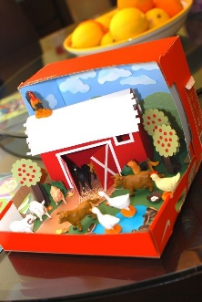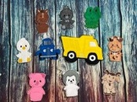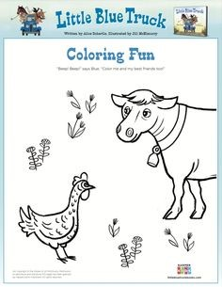

Morphology: **Adjective –y suffix**

To emphasize the versatility of the adjective –y suffix, I will center our attention on this linguistic concept during our collaborative team activity, where we'll construct a detailed farm diorama. Throughout the project, I will actively demonstrate and prompt students to articulate each animal's characteristics. Encouraged responses will encompass vivid and impactful descriptive terms like "smelly," "hairy," "dirty," and "greasy," fostering a nuanced understanding of the adjective –y suffix in a tangible and engaging context.