Children’s Book Assignment

Chloe Ho

CSAD 112

**Book #1:** *When Cows Come Home* by David L. Harrison

Vocabulary word: **Cow**

This story is a fun book which follows a group of cows who sneak off to do fun activities when the farmer is not looking during the day. For this activity, I would first explain to the kids what a cow is, and we would all go around the circle making our best “moooooo” cow impressions. I would also bring in my stuffed animal cow from Chick-fil-A and have them pass it around and name distinctive features of the cow (ex. What color are the cow’s spots?). When they participate, I will let them ring the cow bell.

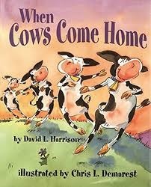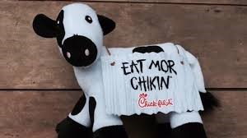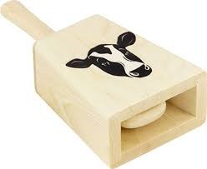

Morphology: **Regular Plural -s**

To teach the kids about what the -s may mean at the end of a word, I will lay out multiple pictures of different nouns to help kids visualize that adding a -s to the end of a noun means there is multiple of them. To first teach them what a noun is, I will lay out pictures of cows, a cow bell, and other nouns with one picture that is NOT a noun mixed in the group. I will then ask them to point to the picture that is NOT a noun out of the group of pictures. Once I feel that the kids can differentiate what a noun is, we will move to the main activity. For this activity, I will bring a set of miniature animal figurines, (including cows), that include multiples of each kind of animal. Then I will write on the whiteboard which animal I want them to find from our “zoo.” If I write the name of the animal without the -s plural indicator, they only need to find one of the animals. However, if the name of the animal I write down does have a -s at the end, they must find as many miniature figurines as possible of that animal in our “zoo.”

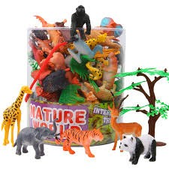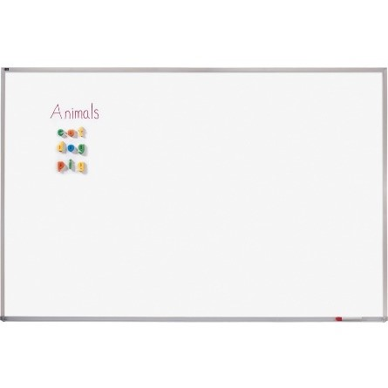

**Book #2:** *The Little Penguin* by A.J Wood

Vocabulary word: **Freeze**

This book is about a penguin living in the snow. I will discuss with the kids what the word freeze means and then lead them in a science experiment involving freezing miniature penguin figurines inside little cups. To prep, the day before I meet with the children, I will follow this [YouTube video](https://www.youtube.com/watch?v=GimJS2mz-bY) (“Ice Experiment - Save The Toys! | Science”) to prepare 2-3 already frozen cubes of ice with the figurines “trapped” inside. On the actual day, I will allow each kid to choose a penguin figurine to “trap” inside ice and have them place their penguin in a small cup and fill the cup with water until the penguin is covered completely. Then, they will place their penguin in the freezer and wait for the water to freeze. Because the figurines will not completely freeze during the time I meet with the kids, I will take out the 2-3 frozen penguins I prepared the day before to show the kids what their penguins will eventually look like. I will explain to them that the water has gotten so cold that it has frozen. Following the guidelines of the same [YouTube video](https://youtu.be/GimJS2mz-bY?si=8YFkWrdWFWagmJ6o), we will slide the block of ice with the penguin in it out of the cup, and I will put the ice cubes in a tub to let the kids start to attempt to melt the ice (and “save” the penguins) by pouring warm water over it.

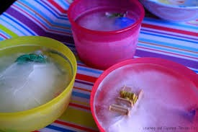

Morphology: **regular past -ed suffix**

To begin with this morphology lesson, I will first explain to them what a suffix is and teach them what the suffix -ed means with various word examples. Then, I will read to the kids *The Little Penguin* and every time we come across a word with the suffix -ed, we will stop and write it down on the whiteboard. At the end of the book, I will pass out printed cutouts of baby penguins with free morphemes written on them, and cutouts of cracked eggshells, with the suffix -ed on them. As they glue the eggshells on the penguins, they will be encouraged to say the now past tense word with -ed aloud.

**Book #3**: *Olive the other Reindeer* by J. Otto Seibold and Vivian Walsh

Vocabulary word: **Sleigh**

This book is about a dog named Olive who thinks that she hears in the “Rudolph the Red Nose Reindeer” song that she is supposed to be one of the reindeers leading Santa’s sleigh. For this activity, I will preorder wooden sleigh making kits where the kids will be able to build their own sleighs. While they are building the sleighs, I will discuss with them what a sleigh does, what it is used for, and what they think it is built out of. They will then get to raise up their own sleigh whenever they see a picture of Santa’s sleigh or hear it mentioned as we are reading the picture book.

Morphology: **adjective suffix -est**

For this morphology lesson, I will first teach and discuss what a suffix is to the kids. I will then describe what the suffix -est means using words with -est found in *Olive the other Reindeer* as examples. I will then lead the kids through an activity involving three assorted sizes of miniature wooden blocks which will represent “presents” that the kids will put in their wooden sleighs. I will then prompt the kids with different superlatives (ex. Put the small*est* “present” in your sleigh or put the pink*est* “present” in your sleigh) and check to see if they put the right “present” in their sleigh.