ARP Spoofing and Man in the Middle attack using Ettercap
Debashis Roy, Katayoon Moazzami and Rachita Singh
School of Computer Science, University of Windsor, Canada
{roy17, moazzam, singh12s}@uwindsor.ca

Abstract
In this paper, we are trying to explain how to do ARP poisoning that allows us to implement the man in the middle attack and to modify the network packets before sending them to the victim. We have used Ettercap tool to perform this attack. Ettercap intercepts the traffic and can modify the payload field of the packet based on some filtering options. The attacker can design the filter to drop, alter or inject new packets. We will also describe some tools such as xarp and arpwatch, which can be used to detect the arp poisoning.

Introduction
A computer connected to an IP/Ethernet LAN has two addresses. One is the MAC address, the address of the network card, which is a globally unique and unchangeable address and is stored on the network card itself. MAC addresses are essential for the Ethernet protocol to send data back and forth, independent of different application protocols. Ethernet builds "frames" of data. Each frame consists of up to 1500 bytes of data. Each frame has an Ethernet header which contains the MAC addresses of the source and the destination computers.
The second address is the IP address. Each computer on a network must have a unique IP address to communicate. IP address is virtual and is assigned via software. Applications use IP protocol independent of whatever network technology operates underneath it.
IP and Ethernet work together. The IP protocol first creates “packets” which has different structure than the frames. But to deliver the packets to Ethernet these have to be changed to frames. So the Ethernet protocol splits the packets into frames, adds Ethernet header to the frames, and sends them down the cable.
When an Ethernet frame is constructed from an IP packet, the MAC address of the destination machine is required to create the Ethernet header. But the Ethernet has no idea about the MAC address of the destination machine. The only information it has is the destination IP from the packet's header. At this point the ARP or the Address Resolution Protocol is used to resolve the MAC address of the destination machine from its IP address.

ARP Operation
ARP operates by sending out "ARP request" packets. An ARP request asks the question, "Is your IP address x.x.x.x? If so, send your MAC back to me." These packets are broadcasted to all computers on the LAN. Each computer examines the ARP request, checks if it is currently assigned the specified IP, and sends an ARP reply containing its MAC address. For example, a host that wants to send a message to IP address 192.168.0.1 on the local network sends a broadcast ARP packet that requests the MAC for that IP. The host that owns the IP 192.168.0.1 returns an ARP reply packet with its MAC address. The requesting host then sends the message, and stores the IP-to-MAC mapping for future packets.
To minimize the number of ARP requests being broadcasted, operating systems keep a cache of ARP replies. When a computer receives an ARP reply, it will update its ARP cache with the new IP/MAC association, regardless of whether they have sent out an actual request. If the MAC address reported in the packet for the given IP has changed, the new value will overwrite the old one in the cache. ARP replies are unicast packets directed at one machine, and cause only that machine to update its cache.

ARP spoofing
ARP spoofing, “also referred to as ARP poison routing (APR) or ARP cache poisoning, a method of attacking an Ethernet LAN by updating the target computer’s ARP cache with both a forged ARP request and reply packets in an effort to change the Layer 2 Ethernet MAC address (i.e., the address of the network card) to one that the attacker can monitor. Because the ARP replies have been forged, the target computer sends frames that were meant for the original destination to the attacker’s computer first so the frames can be read. A successful ARP attempt is invisible to the user” [1].
The principle of ARP spoofing is to send fake or spoofed ARP messages to an Ethernet LAN. Generally the attacker's MAC address is associated with the IP address of another node (such as the default gateway). As a result any traffic meant for that IP address will be sent to the attacker instead. The attacker could then choose to forward the traffic to the actual default gateway (passive sniffing) or modify the data before forwarding it (man-in-the-middle attack). The attacker can also launch a Denial of Service attack against a victim by associating a nonexistent MAC address to the IP address of the victim's default gateway [2].
ARP poisoning makes possible many sorts of “man in the middle” attacks. Let us consider an example. The attacker, host C, sends an ARP reply to B stating that A’s IP maps to C’s MAC address, and another ARP reply to A stating that B’s IP maps to C’s MAC address (Figure 1). As ARP is a stateless protocol, hosts A and B assume that they sent ARP requests at sometime and update their ARP caches with this new information.

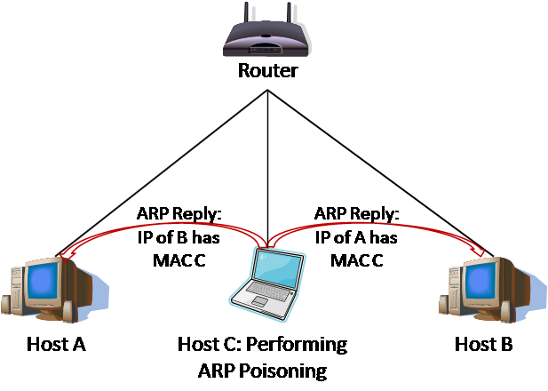
Figure 1: Setting up a man in the middle attack by C against A and B by poisoning ARP caches.

After ARP poisoning is successful, when A tries to send a packet to B it will go to C instead. Host C now can forward the packets on to the correct host and monitor or modify them as they pass through C (Figure 2).

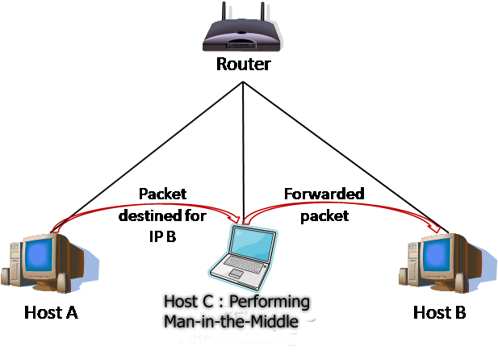
Figure 2: C performs a man in the middle attack against A and B, most likely without being detected.

This man in the middle attack allows C to monitor or modify telnet sessions, read mail passing over POP or SMTP, intercept SSH negotiations, monitor and display Web usage, and commit many other nefarious activities. “The ARP cache poisoning attack can be used against all machines in the same broadcast domain as the attacker. Hence, it works over hubs, bridges, and switches, but not across routers. An attacker can, in fact, poison the ARP cache of the router itself, but the router won't pass the ARP packets along to its other links. Switches with port security features that bind MAC addresses to individual ports do not prevent this attack since no MAC addresses are actually changed. The attack occurs at a higher network layer, the IP layer, which the switch does not monitor.” [4]

Man-in-the-Middle Attack
Man-in-the-Middle attacks are a derivative of packet sniffing. “Instead of listening to all packets that pass through a network, man-in-the-middle attacks attempt to pick one or more hosts to interfere with.”[3] By logically getting between the victim's machine and the gateway or router, an attacker can alter traffic and force unintended consequences for the victim. Using ARP-poisoning also called ARP spoofing, the attacker can get and associate certain IP addresses with certain Media Access Control using Address Resolution Protocol. These start by communicating with the gateway that the victim's IP address belongs to the attacker's MAC address. Next, they convince the victim that the gateway's IP address belongs to the attacker's MAC address. Lastly, packets bound for the gateway pass through the attacker's interface before reaching the gateway and gateway packets bound for the victim pass through the attacker's interface before getting forwarded to the victim. This allows the man-in-the-middle to change the traffic using filters.

Namp
“Nmap is a free security scanner written by Fyodor. It is used to evaluate the security of computers, and to discover services or servers on a computer network.”[7] We have used Nmap to get the list of all the hosts of the network which are currently up.
Features
Nmap features include:
- Host Discovery - Identifying computers on a network, for example listing the computers which respond to pings, or which have a particular port open
- Port Scanning - Enumerating the open ports on one or more target computers
- Version Detection - Interrogating listening network services listening on remote computers to determine the application name and version number.
- OS Detection - Remotely determining the operating system and some hardware characteristics of network devices.
Platforms
Nmap runs on Unix-like systems such as Linux, Solaris, Mac OS X, and BSD, and also on Microsoft Windows and AmigaOS. We can download nmap from www.insecure.org/nmap.

Ettercap
Ettercap is an open source Unix tool licensed under the GNU General Public License. It can be used for security checking and network analysis. It can stop the traffic in a part of the network, capture passwords and peform a man in the middle attack. Some other attacks that this tool is capable of are: character injection, packet filtering, password collection and killing the connection.
We are using this tool for packet filtering which is filtering the TCP or UDP packets and searching for a specific string (in ASCI or hexadecimal form) in them and finally replacing that string with the string of your choice. We also use this tool for packet forging and changing the content of the web browser on the victims system.
There are many useful features included in the Ettercap that enables it to recognize the OS, open ports, IP and MAC addresses on the other computers in the network.

Ettercap Plugins
The Ettercap includes a variety of plug ins which are of two kinds, hooking and external plugins. Hooking plugins accept sniffed data from the victims system from the Ettercap sniffing engine. External plugins don’t accept data directly from the sniffing engine.

Modes of Operation
Ettercap offers four modes of operation:[9]
- IP-based: packets are filtered based on IP source and destination.
- MAC-based: packets are filtered based on MAC address, useful for sniffing connections through a gateway.
- ARP-based: uses ARP poisoning to sniff on a switched LAN between two hosts (full-duplex).
- PublicARP-based: uses ARP poisoning to sniff on a switched LAN from a victim host to all other hosts (half-duplex).

Other features of Ettercap
There are some other features like:
- Character injection into an established connection
- SSH1 support
- SSH1 connection
- HTTPS support.
- Plug-in support
- Password collectors for so different protocols
- Packet filtering/dropping
- OS finger printing
- Kill a connection
- Passive scanning of the LAN
- Finding other poisenners in the LAN

Installing Ettercap
Ettercap can be downloaded online in http://ettercap.sourceforge.net/ either for windows or linux. There are certain libraries that must be installed before installing the Ettercap, e.g., libpcap 0.8.1, libnet 1.1.2.1, libpthread and zlib. Some other optional libraries can also be installed along with the ettercap, these are: libltdl, libpcre,openssl 0.9.7 ,ncurses 5.3, pkgconfig 0.15.0, glib 2.4.x, gtk 2.4.x, atk 1.6.x and pango 1.4.
For using the http sniffing tools we must first install the openssl that allows support for SSL and TLS, openssl can be downloaded from http://www.openssl.org.
The most recent ettercap version is NG-0.7.3, after downloading ettercap-NG-0.7.3.tar.gz, we uncompress this file and save it. Now we will enter in the command line:
# cd ettercap_0.7.3
# ./configure
# make install

Using Ettercap
We can use the ettercap by typing “ettercap” in the command line.
When ettercap starts it sends an ARP request to all the computers in its subnet so that it can know every computer’s MAC address.
As we intend to perform ARP poisoning there are several options in ettercap we can use. By now ettercap knows about all the hosts in the network that responded to the ARP request broadcasted earlier by the ettercap but there are options that can be useful in getting more information about the network.
These are some of the options that can be used with ettercap command:
c Search for other ARP poisoners on the LAN
f Fingerprint the selected host’s operating system and services
k Manually save the map of discovered hosts to a file
x Packet Forge – craft customized packets
p Run a plugin that does not rely on ARP poisoning

Filters and Character Injection
Ettercap uses filters to search for and replace arbitrary text or hexadecimal strings in data streams before they are forwarded to the destination host. If the victim hosts are poisoned and the filter is enabled so the DNS traffic will be changed and the victim will receive incorrect or harmful data from a valid DNS request.
Ettercap can also inject additional characters into an active data stream. It is even possible to inject new commands to a server as if they came from the client, or vice versa.

Defence against Ettercap
One of the tools that can be used for detecting an ettercap attack is arpwatch. This linux tool monitors the network for changing ARP data and watches for ARP attack signatures. Arpwatch maintains a database of current IP and MAC address mappings, and can report changes to this database through email. Ettercap can also be used to watch for ARP attack signatures. For windows there is similar tool XARP which continuously monitors the ARP cache.
Also any host or network administrator can use a plugin named H00_lurker to interactively detect other systems using ettercap on the LAN. A properly configured intrusion detection system will probably notice the startup of ARP storm and the crafted ARP Reply packets and notify the network security personnel that there is an ARP poisoning operation taking place in the network.[8]

ArpWatch
Arpwatch is a tool for detecting ARP poisoning which monitors ethernet activity and it maintains a database of Ethernet MAC addresses seen on the network, with their associated IP pairs. It can report the changes via email. “Arpwatch uses libpcap, a system-independent interface for user-level packet capture.” [6]

XARP
XArp is a tool that runs on Windows for ARP spoofing detection. It is a small but useful graphical tool to monitor the ARP cache of our computer. It periodically requests the local ARP cache. As it reports changes in the IP to MAC mapping by comparing the new entries against the old ones. Thus XArp can be used to recognize ARP poisoning which is used to prepare 'man in the middle' attacks.[5]

Conclusion
An attacker can use ettercap to launch a man-in-the-middle attack very easily once he has a LAN connection. Most tools cannot detect the attack launched by Ettercap and the most effective way to detect this attack is to monitor the ARP cache using any network monitoring tool.

References
[1] ARP spoofing, http://www.webopedia.com/TER/ A/ARP_spoofing.html
[2] ARP spoofing, http://en.wikipedia.org/wiki/ARP_spoofing
[3] Wireless Man in the Middle Attack Part I, http://blogs.ittoolbox.com/wireless/networks/archives/wireless-man-in-the-middle-attack-part-i-7422
[4] Wireless Access Point and ARP Poisoning, http://www.packetnexus.com/docs/arppoison.pdf
[5] Xarp 0.1, http://www.governmentsecurity.org/ archive/t9274.html
[6] ARPwatch, http://www.securityfocus.com/tools/142
[7] Nmap, http://en.wikipedia.org/wiki/Nmap
[8] An Ettercap Primer , https://www2.sans.org/ reading_room/whitepapers/tools/1406.php?portal=9b1a0c905186c3963b683660224c6b0b
[9] ETTERCAP – An Easy Tutorial, http://www.openmaniak.com/ettercap.php

